OMESHA
RAVIHARI
PERSONAL PROFILE

071 483 8087 077 881 2159
omesharavihari96@gmail.com
No. 7 Imbula Road,
Olaboduwa, Gonapola
Junction

Language
• Sinhala English

Skill Highlights
- Multi-tasking
- Time Management
- Inventory Management
- Point of Sale (POS) Operation
- Problem-Solving
- Stock Control
NAME IN FULL | : Weerakkody Appuhamilage Omesha Ravihari
DATE OF BIRTH | : 02.10.1996
AGE | : 29
GENDER | : Female
NIC | : 199677601486
NATIONALITY | : Sri Lankan
RELIGION | : Buddhist
CIVIL STATUS | : Unmarried
- Health & Safety Compliance Experience
JULY 2017 - Current (8 Years)
Store Assistant • C & D International (PVT) Ltd

Education
G.C.E O/L Examination (Sinhala Medium) 2012
Lang. & Lit (S)
Home Econom
Buddhism
Science
Mathamatics
History
Dancing (ORI)
Citi. Edu
English

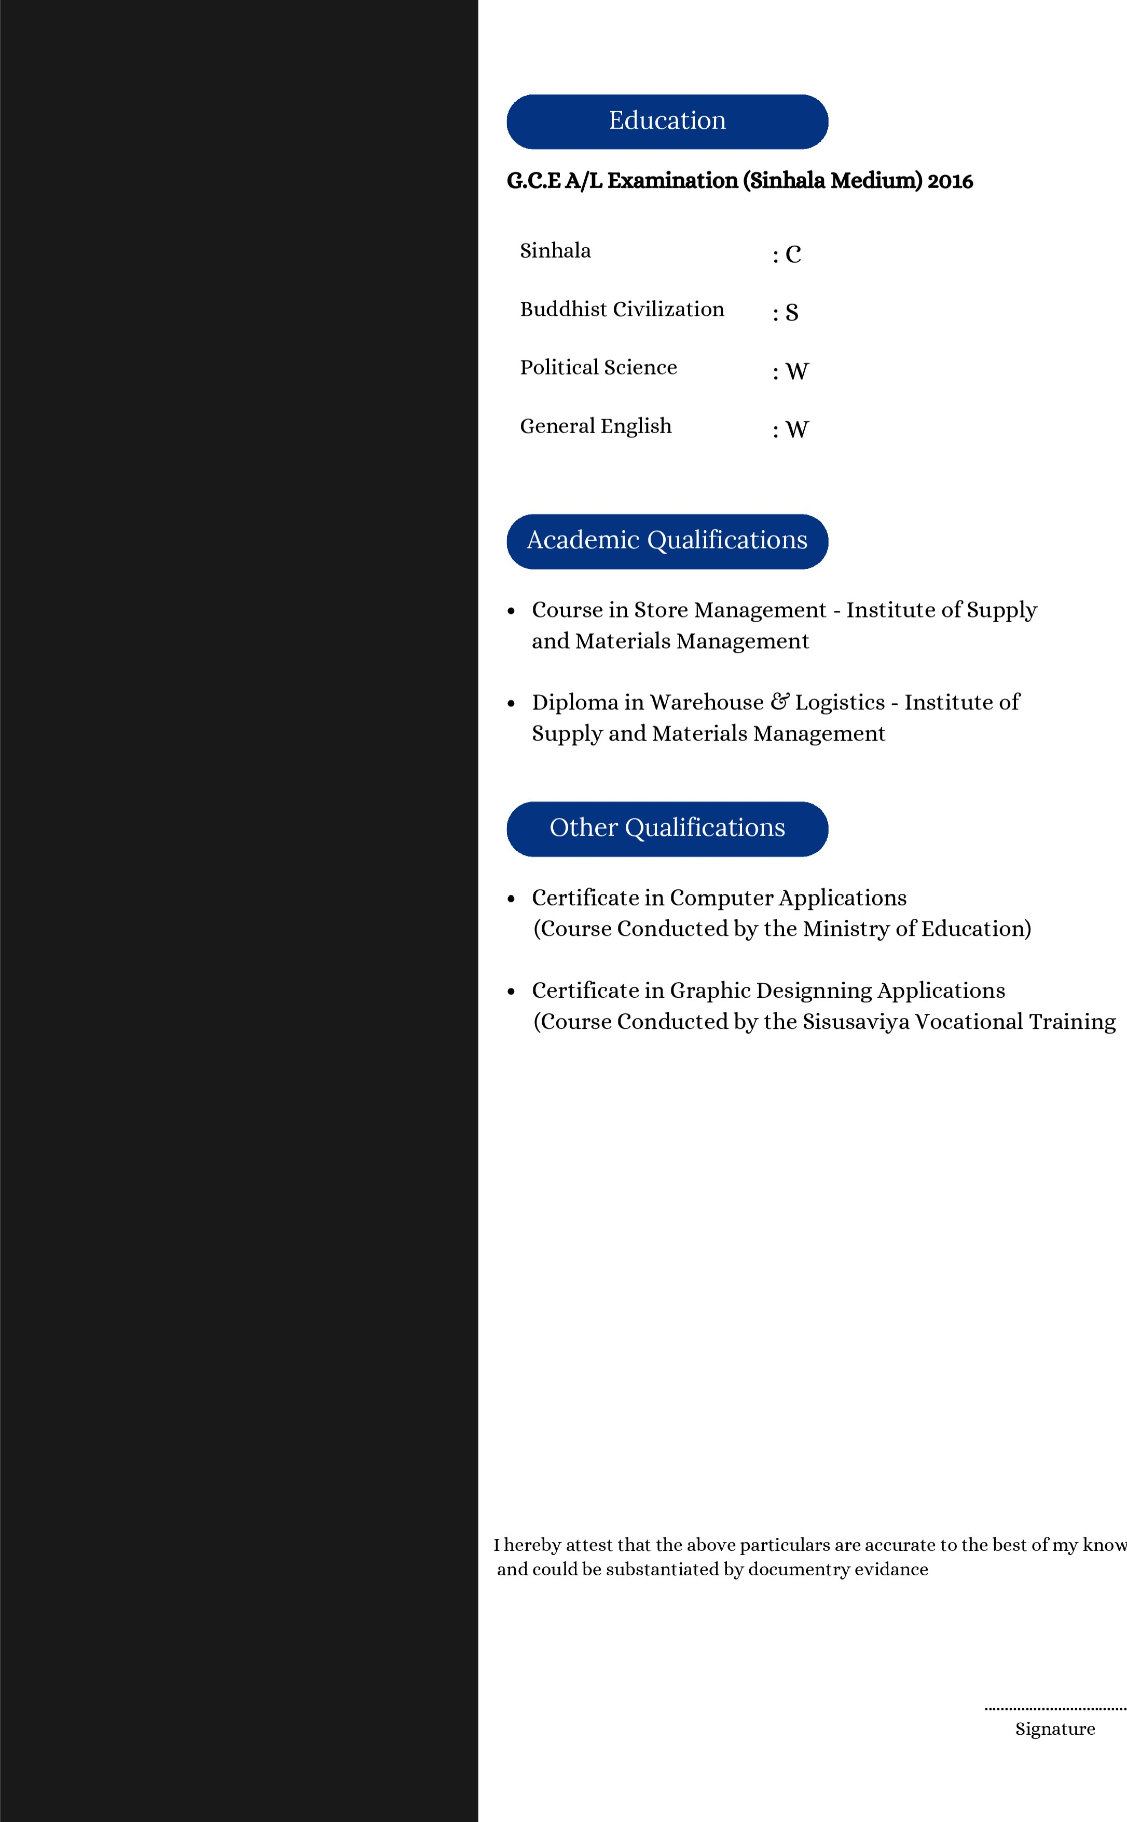
• Certificate in Graphic Designning Applications
Center)
knowledge
and could be substantiated by documentry evidance
Signature

