OBJECTIVE



SINHALA
ENGLISH
TAMIL

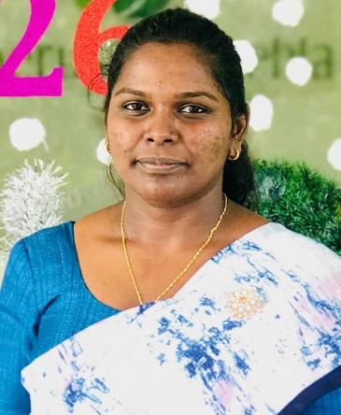
Human Resource & Administrative assistant with 3 years of experience and self – driven, hardworking, flexible individual, who looking forward to grow my career by talking up a role in Human Resource & Administration by working on new HR process & policies couples with their implementation.

EDUCATION
• G.C.E A/L 2019 - P. M. Perera Vidyalaya
- Economics B
- Business Studies C
- Accounting C

• G.C.E 0/L 2016 – Royal College Horana

- Buddhism A
- Sinhala A
- Mathematics A
- History B
- Dancing B
- Science C
- English C
- Home Science C
- Tamil S

S.S.M. IMALKA SEWWANDI BANDARA

CONTACTS

076 358 0168
sewwandibandara.dobagaskanda@
gmail.com
468, Wijaya Govi Janapadaya, Dobagaskanda, Ingiriya.

PROFESSIONAL QUALIFICATIONS

- Working as a Human Resource & Administrative at Hesperus Naturehla (Pvt) Ltd since 2023.

- Working as Quality Checker at Unichela (Pvt) Ltd in 2020.

- Followed the Diploma in Human Resource Management at SITC Campus.

- Followed the Diploma in Computer Science at D-Tec Gampaha District Training.

LANGUAGES

SKILLS
Extra Curricular Activities
- Creative Thinking Skills
- Hardworking
- Good Communication Skills
- Organizational & Time Management Skills
- Microsoft Office Package
- Leadership & Team Work
- Self-Motivation

              - Student Prefect (2015-2016)- P. M. Perera Vidyalaya, Batuwita, Horana.
              - Participated in Athletic Events at the School Level.
              - Secretary of Literature Society - P. M. Perera Vidyalaya, Batuwita, Horana.
              - Member of school commerce society – Royal College, Horana.

- M
i

Reference

Miss. K.K. Kulangika Premathilaka, Miss. Yohani Amritha Walpita,
Sri Lanka Administrative Service ( Grade III) Officer, Senior Chemist – Quality Assurance & Research & Development
Ministry of Public Administration, Provincial Councils Super Colids Lanka (PVT) Ltd,
& Local government. No:75, Mandawala Road, Panadura.
071 446 6032. 077 843 6959
Kulangika93@gmail.com

.

S.S.M. Imalka Sewwandi
30/04/2026.

